FACE RECOGNITION ATTENDANCE SYSTEM

Ankit Kushwaha, Gayatri Kumari, and Niket Dujari
Guided by: Prof. Amit Kumar V. Jha

Abstract- To ensure that there is discipline among students and to ensure that students get utmost knowledge, the attendance system was introduced in school, colleges and universities. There are mainly two methods to mark the attendance of a student. The first is where the person-in-charge calls out the roll number of the student and the second method is to take the student signature on a paper against his/her roll number. A large number of applications can be made around this idea, which will not only help save time, but also eliminate the chance of proxy attendance due to its effective identification. The main objective behind this project is to build an Automated Attendance System using Python Language and with the help of OpenCV/Python libraries and recognizer algorithm. The proposed application can be used in any institution or field, where attendance system is present and plays a vital role in the working of that institution. It can be said that this project is an effective solution for all universities and colleges to track and manage the regular attendance of it’s students .
Keywords- OpenCV , face recognition, computer vision,attendance system

- Introduction
The fast-growing technology is imparting a magnificent amount of knowledge-oriented technical ideas and innovations. Deep Learning is one of the most interesting technology in which the machine trains itself after we provide it with some datasets as an input and then, the machine applies different learning algorithms and then provides the corresponding output. In today’s world, attendance of a student is considered to be very important for the student as well as the management faculty of an institution. With the advancement in the field of deep learning technology [1], the machine can now detect the attendance of the student by just his/her face and also maintains a record of the data collected by it. Broadly, the attendance of a student can be recorded and maintained in 2 ways, which are:
- Manual Attendance System (MAS) •
- Automated Attendance System (AAS).
In,Manual Student Attendance Management system, a faculty concerned with the particular subject calls out the students name/roll number and then marks the attendance if he/she is present,manually. Manual attendance can be a time-consuming or hectic process and in some cases, the teacher may miss or skip someone’s name or a particular student may answer multiple times on behalf of his absent friends which is called a proxy attendance . So, there are many problems associated with the conventional process of taking manual attendance in the classroom. To overcome these negative points, we opt for Automatic Attendance System (AAS) .
Automated Attendance System (AAS) is a process in which the presence or the absence of a particular student in the classroom is automatically detected by using face recognition technology and Deep Learning. In addition to this, it is also possible to detect whether the student has slept during the lecture or whether he/she is awake during the lectures. This system can also be implemented during an exam to ensure that the student is present. The presence of a student in a class can be determined by capturing their face on a high-definition camera or video device, so that it is very easy for the machine to detect the presence of all the students in the classroom.

- Proposed Model
All pupils must register by providing the requested information, after which their images will be collected and saved on the website. Faces will be seen in the class live streaming video during each session. Faces discovered will be compared to photos already in the data collection. Attendees will be assigned to the proper student after the match is received. A list of those who will be absent will be submitted to the appropriate faculty in charge of the session at the end of each session. The suggested system's structure is shown below.
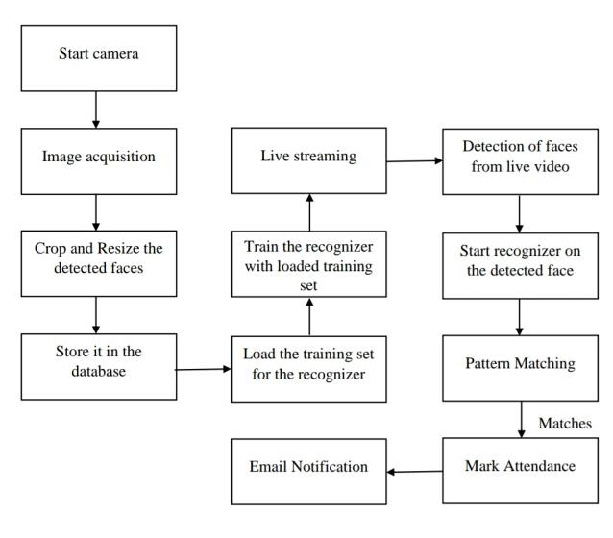
Fig.1.System Architecture
The suggested system's purpose is to capture each student's face and save it on the website for them to visit. The student's face must be photographed in such a way that all of the student's features can be seen. Because the application records a video and the face recognition process is monitored, the teacher does not need to be physically present in the classroom. The attendance website is also updated. The Python OpenCV library was used to develop this programme.
Basically this process can be divided into four processes,
- Creation of Dataset
A webcam is used to take images of the students. By touching different bodies and perspectives, you can get a lot of images of one pupil. These images have been processed before. Images are taken to determine the Interest Rate (ROI) [2] to be used in the recognition process.
- Face Detection
Face detection is done using the Haar-Cascade Classifier [3] with OpenCV. The Haar Cascade algorithm requires training to identify a person's face before it can be used for face detection. This is called a feature release. The haar cascade training data used is an xml file haarcascade_frontal face_default. Haar features will be used to remove the feature.

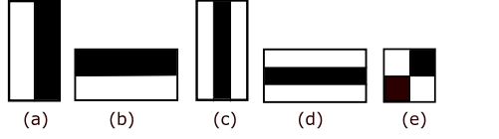
Fig.2.Types of Haar-like features. (a) Left-right. (b) Top-bottom. (c) Vertical-middle. (d) Horizontal-middle. (e) Diagonal.
- Face Recognition
Training data preparation, facial recognition and speculation are the three processes in the facial recognition process. The training data will be in the form of photographs on the website. They'll be issued a full label for the incorrect pupil. Face recognition is then performed using these photos. Local Binary Pattern Histogram face expressions are employed in this application. Initially, a list of local binary patterns (LBP) [4] for all faces is available.
- Updated Attendance
Following the facial recognition procedure, known faces will be noted as present on the excel sheet, while all others will be marked as missing, with a list of practitioners being forwarded to the appropriate teachers. At the conclusion of each month, teachers will be notified of the monthly attendance sheet.
- results
A graphical user interface (GUI) [5] is available for users to interact with the system. Users will primarily be given two options: student registration and attendance marking. Students must fill out the student registration form (Fig.3) with all of the essential information. The web cam starts immediately once you click the register button, and a popup like the one shown in Fig.4 appears, detecting faces in the frame. The camera will then begin taking pictures automatically until 60 samples have been obtained or CRTL+Q has been hit. After that, the photographs will be pre-processed and saved in a folder called training images. Faculty members are required to fill out the faculty registration form with their unique course codes and email addresses. This is significant because the list of absentees will be mailed to the respective faculties at the end of the semester.

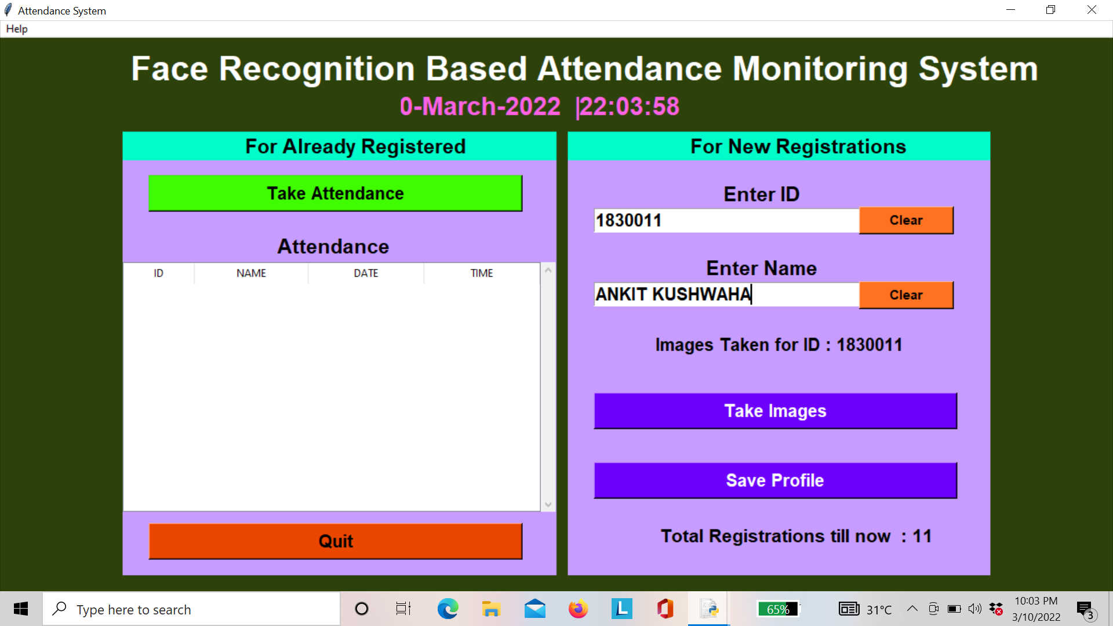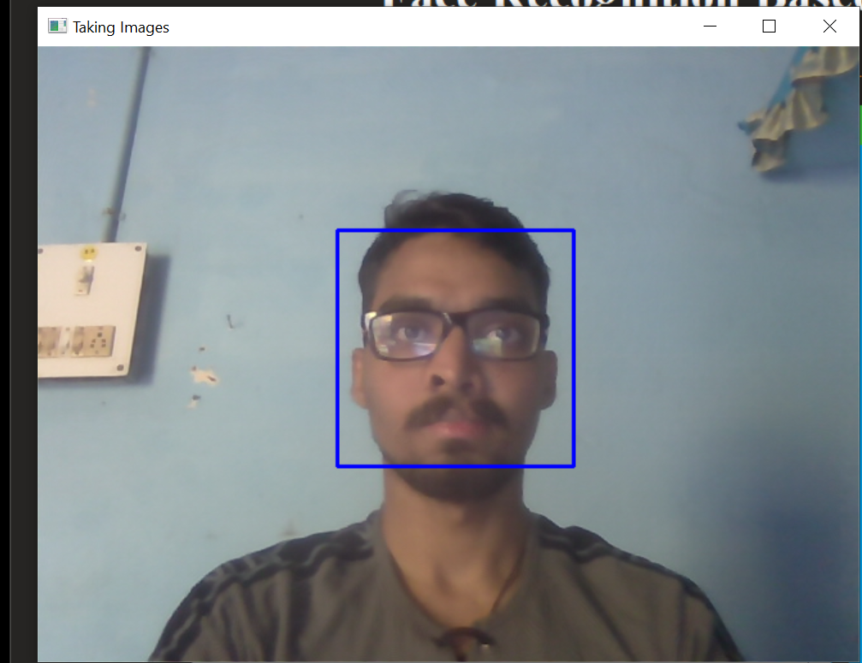
Fig.3. Registration form Fig.4.Face Detection
Then after successfully saved profile, the camera will turn off automatically after taking 100 sample. Fig 5 depicts the facial recognition window, which recognises registered pupils and displays 'unknown' if they were not registered. The window will dismiss when you hit CTRL+Q, and the attendance will be updated in the excel sheet and the names of absentees will be emailed to the relevant faculty.

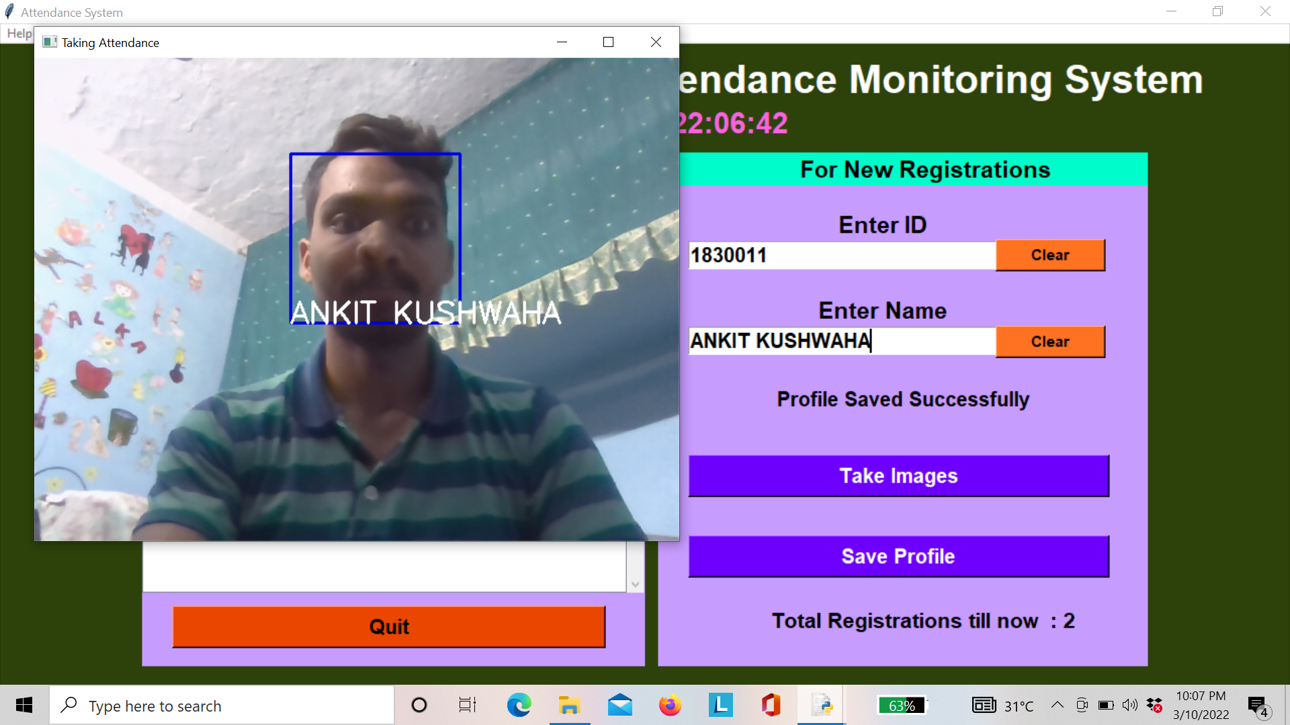
Fig.5.Face Recognition
Fig.6. shows the updated attendance sheet after recognition process.After successful attendance, details are automatically updated in database and shown in your attendance list with date and time.Old registered users can directly click on take attendance button, if not registered it shows unknown name.

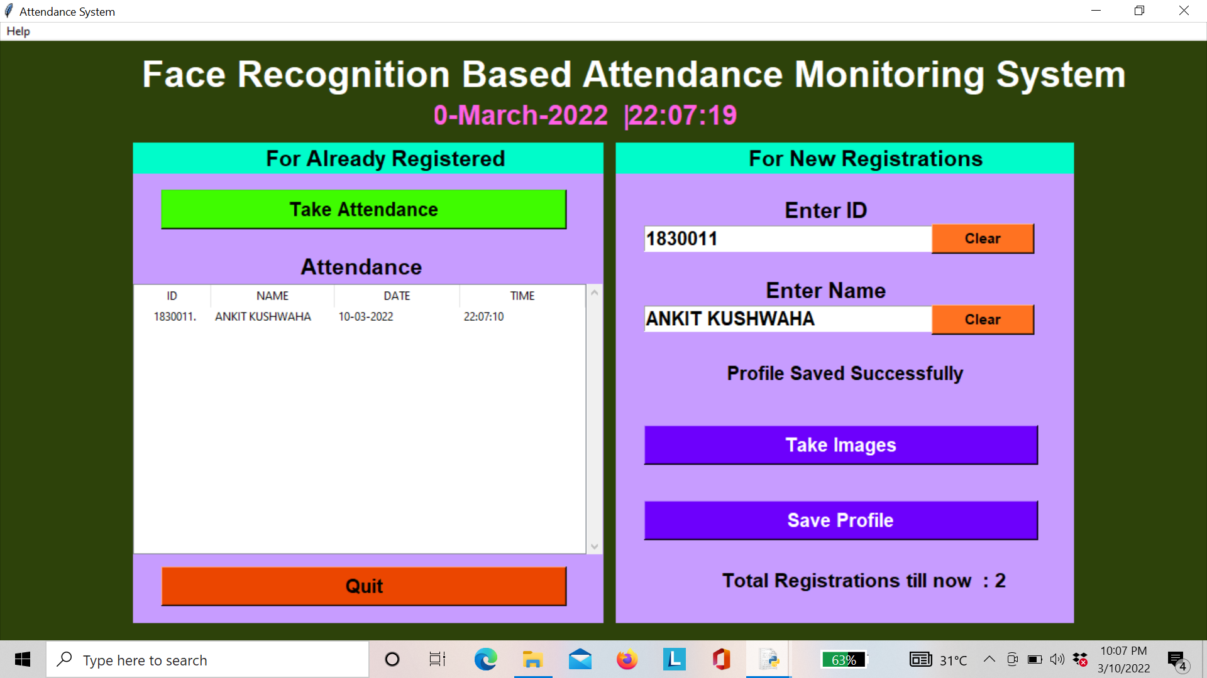

Fig.6. Updated Attendance Sheet

- CONCLUSION
The main objective of this project is to build an effective class attendance system using face recognition technique. The system will be able to mark the attendance of a student via his/her face Id. It will detect the face via the webcam of the computer and then recognize the face. After recognizing the face, it will mark the attendance of the student and update it in the system.we chose the Automated attendance system using face recognition topic, keeping in mind of the day to day needs and wants of the modern education system.The advancements in technology had lead us to think out of the box and come up with an idea that would not only be future changing but will also be very helpful.Education is the most important thing which person must acquire, as it is one of the basics for a better lifestyle and will surely elevate the standards of a living community.The thing which our current education system lacks is the presence and involvement of students in the schools, colleges and universities. Instead of attending lectures and studying, they rather prefer skipping the class and keep themselves engaged in using gadgets or playing.Low attendance results in that students inability to acquire the knowledge which he/she are supposed to get and is very important for them and can lead them to a better and bright future.

References

- Al-Amoudi, I., Samad, R., Abdullah, N. R. H., Mustafa, M., & Pebrianti, D. (2022). Automatic Attendance System Using Face Recognition with Deep Learning Algorithm. In Proceedings of the 12th National Technical Seminar on Unmanned System Technology 2020 (pp. 573-588). Springer, Singapore..
[2] Sun, X., Zheng, S., & Fu, H. (2020). ROI-attention vectorized CNN model for static facial expression recognition. IEEE Access, 8, 7183-7194.
[3] Minu, M. S., Arun, K., Tiwari, A., & Rampuria, P. (2020). Face recognition system based on haar cascade classifier. International Journal of Advanced Science and Technology, 29(5), 3799.
[4] Tang, J., Su, Q., Su, B., Fong, S., Cao, W., & Gong, X. (2020). Parallel ensemble learning of convolutional neural networks and local binary patterns for face recognition. Computer Methods and Programs in Biomedicine, 197, 105622.
[5] Yusof, Y. W. M., Nasir, M. M., Othman, K. A., Suliman, S. I., Shahbudin, S., & Mohamad, R. (2018). Real-time internet based attendance using face recognition system. International Journal of Engineering & Technology, 7(3.15), 174-178.

